**ASSIGNMENT-01**

**BASIC PYTHON**

|  |  |
| --- | --- |
| **Assignment Date** | 12 september 2022 |
| **Student Name** | Miridini V |
| **Student Roll Number** | 113219071019 |
| **Maximum Marks** | 2 Marks |

**QUESTION-01:**

## 1. Split this string

s **=** "Hi there Sam!"

**SOLUTION:**

['Hi', 'there', 'Sam!']

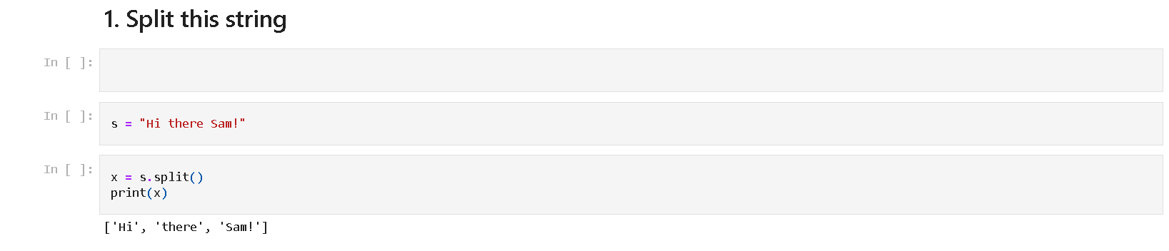

**QUESTION-02:**

## 2. Use .format() to print the following string.

### Output should be: The diameter of Earth is 12742 kilometers.

planet **=** "Earth"

diameter **=** 12742

**SOLUTION:**

The diameter of Earth is 12742 kilometers

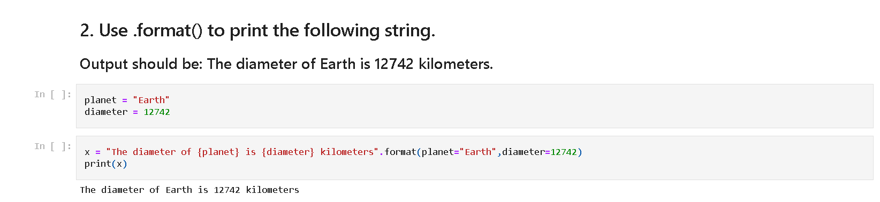

**QUESTION-03:**

## 3. In this nest dictionary grab the word "hello"

d **=** {'k1':[1,2,3,{'tricky':['oh','man','inception',{'target':[1,2,3,'hello']}]}]}

**SOLUTION:**

hello

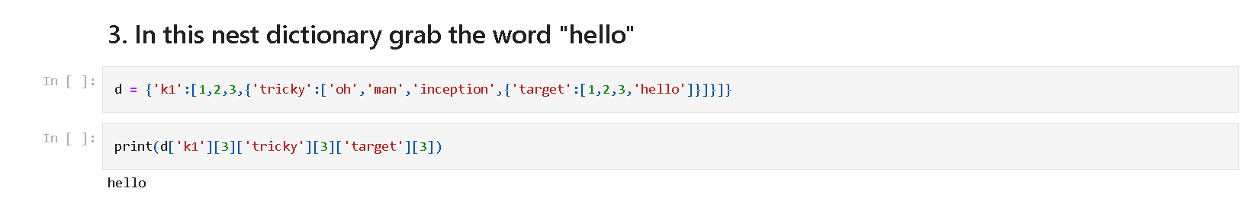

**QUESTION-04:**

# Numpy

**import** numpy **as** np

## 4.1 Create an array of 10 zeros?

## 4.2 Create an array of 10 fives?

**SOLUTION:**

array([0., 0., 0., 0., 0., 0., 0., 0., 0., 0.])

array([5., 5., 5., 5., 5., 5., 5., 5., 5., 5.])

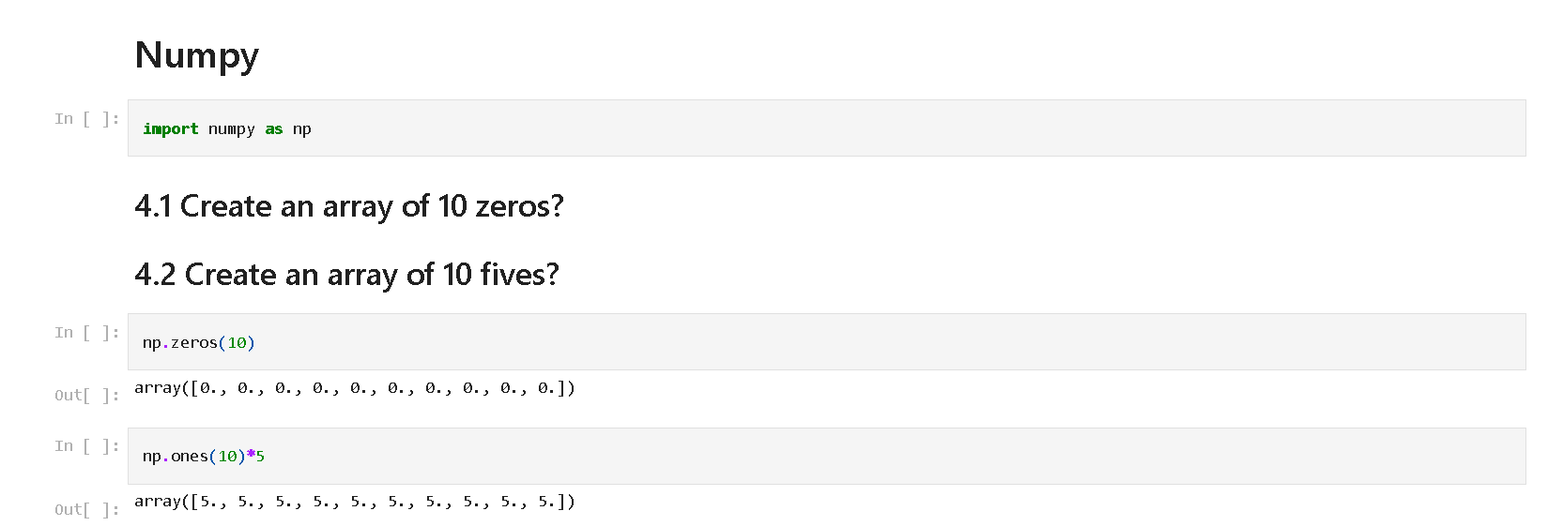

**QUESTION-05:**

## 5. Create an array of all the even integers from 20 to 35

**SOLUTION:**

array([20, 22, 24, 26, 28, 30, 32, 34])

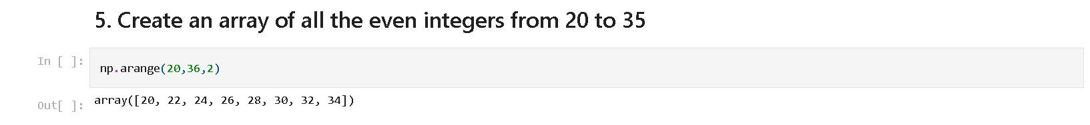

**QUESTION-06:**

## 6. Create a 3x3 matrix with values ranging from 0 to 8

## SOLUTION:

array([[0, 1, 2],

[3, 4, 5],

[6, 7, 8]])

## 

## QUESTION-07:

## 7. Concatenate a and b

## a = np.array([1, 2, 3]), b = np.array([4, 5, 6])

## SOLUTION:

array([1, 2, 3, 4, 5, 6])

## 

## QUESTION-08:

# Pandas

## 8. Create a dataframe with 3 rows and 2 columns

**import** pandas **as** pd

## SOLUTION:

col1 col2

0 1 4

1 2 5

2 3 6

## 

## QUESTION-09:

## 9. Generate the series of dates from 1st Jan, 2023 to 10th Feb, 2023

## SOLUTION:

2023-01-01 00:00:00

2023-01-02 00:00:00

2023-01-03 00:00:00

2023-01-04 00:00:00

2023-01-05 00:00:00

2023-01-06 00:00:00

2023-01-07 00:00:00

2023-01-08 00:00:00

2023-01-09 00:00:00

2023-01-10 00:00:00

2023-01-11 00:00:00

2023-01-12 00:00:00

2023-01-13 00:00:00

2023-01-14 00:00:00

2023-01-15 00:00:00

2023-01-16 00:00:00

2023-01-17 00:00:00

2023-01-18 00:00:00

2023-01-19 00:00:00

2023-01-20 00:00:00

2023-01-21 00:00:00

2023-01-22 00:00:00

2023-01-23 00:00:00

2023-01-24 00:00:00

2023-01-25 00:00:00

2023-01-26 00:00:00

2023-01-27 00:00:00

2023-01-28 00:00:00

2023-01-29 00:00:00

2023-01-30 00:00:00

2023-01-31 00:00:00

2023-02-01 00:00:00

2023-02-02 00:00:00

2023-02-03 00:00:00

2023-02-04 00:00:00

2023-02-05 00:00:00

2023-02-06 00:00:00

2023-02-07 00:00:00

2023-02-08 00:00:00

2023-02-09 00:00:00

2023-02-10 00:00:00

## 

## 

## QUESTION-10:

## 10. Create 2D list to DataFrame

lists = [[1, 'aaa', 22], [2, 'bbb', 25], [3, 'ccc', 24]]

## SOLUTION:

0 1 2

0 1 aaa 22

1 2 bbb 25

2 3 ccc 24

## 